
Company
Logotype

Cone Beam Computed Tomography- Report



Porur Dental X-rays & CBCT

Patient Name : Mrs. Rani | Date of Report : 22.04.2024
Age/ Gender : 65 years/ Female | Region of Interest : CBCT Sectional Mandible
Referring doctor: Dr. Sheethalan | Indication : Implant assessment
Clinical Notes: Nil
PATIENT INFORMATION

CBCT- Sectional Mandible provided
CBCT – IMAGE DETAILS

RADIOGRAPHIC INTERPRETATION

- In relation to 46, presence of restorative material in relation to the pulp canal extending upto the apical third of the roots is evident.
- The alveolar bone in relation to 36, 37, 47 is present with normal trabecular pattern.

IMPLANT ASSESSMENT

 | 36 region | 37 region | 47 region
Sub-Crestal (in mm) | 5.28 | 6.79 | 7.76
Mid- Crestal (in mm) | 8.29 | 9.05 | 12.21
Distance between alveolar ridge and the inferior alveolar nerve canal (in mm) | 16.55 | 15.75 | 15.34
Distance between alveolar ridge and the inferior border of mandible (in mm) | 27.27 | 27.83 | 25.65

RADIOGRAPHIC IMPRESSION

- Root canal treated: 46
- Implant assessment done in relation to 36, 37, 47.

Kindly correlate with clinical findings


IMAGES FOR REFERENCE

RECONSTRUCTED PANORAMIC VIEW

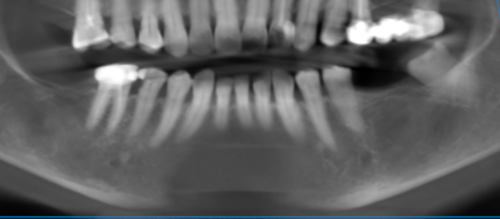

3-DIMENSIONAL VIEW

CROSS SECTIONAL VIEW

36 region | 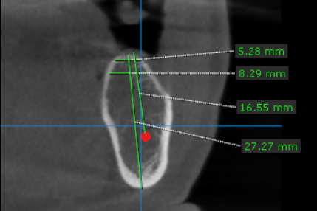
37 region | 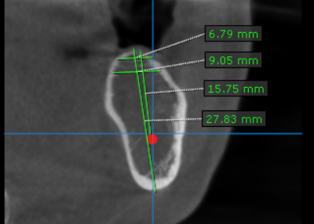
47 region | 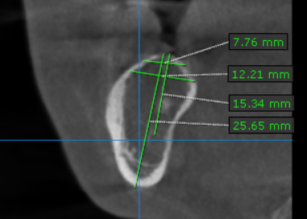

**** End of report ****

